**LED FLASHER**

Aim: -To make a LED flasher

Hardwares Used:-

Breadboard, Arduino board, resistor, connecting wires, LED

Circuit Diagram

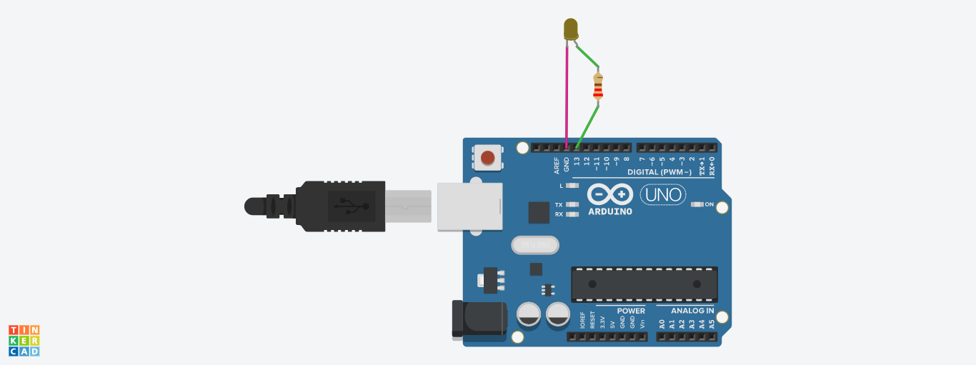

Theory

Concept Used:-

In this the concept used is connecting the LED properly in the Arduino board with proper code and proper connections.

Learnings & observations

From the experiment of led chaser we learned about the Arduino board as well as the Arduino software and the basic terms used in this experiment of Arduino Uno and the LEDs were also being learnt.

Problems & Troubleshooting

* The Connections were not properly connected at the very first time. Then we looked at it consciously and found our mistakes.
* There were difficulties while looking for anode and cathode but understood after we used it several times.
* The concept of breadboard was also a typical case, we were confused about the connections in breadboard.

Precautions

1. The connections were not tight.
2. The LED might be fused.
3. Don’t connect the Arduino board to the computer until and unless the code is to be uploaded on it.

Learning Outcomes

1. From this experiment we learnt about Arduino board.
2. Learnt about LED flasher.
3. Learnt about breadboards.